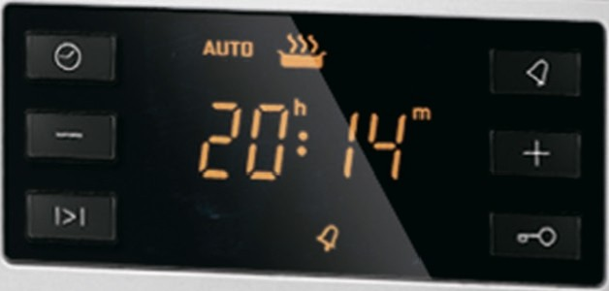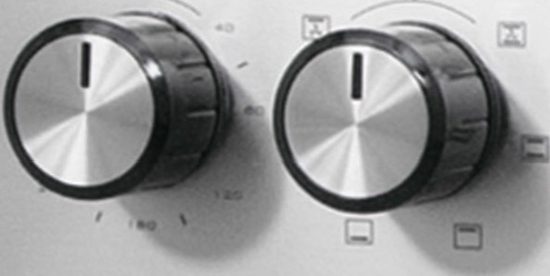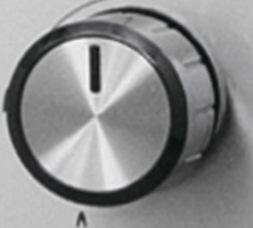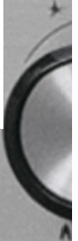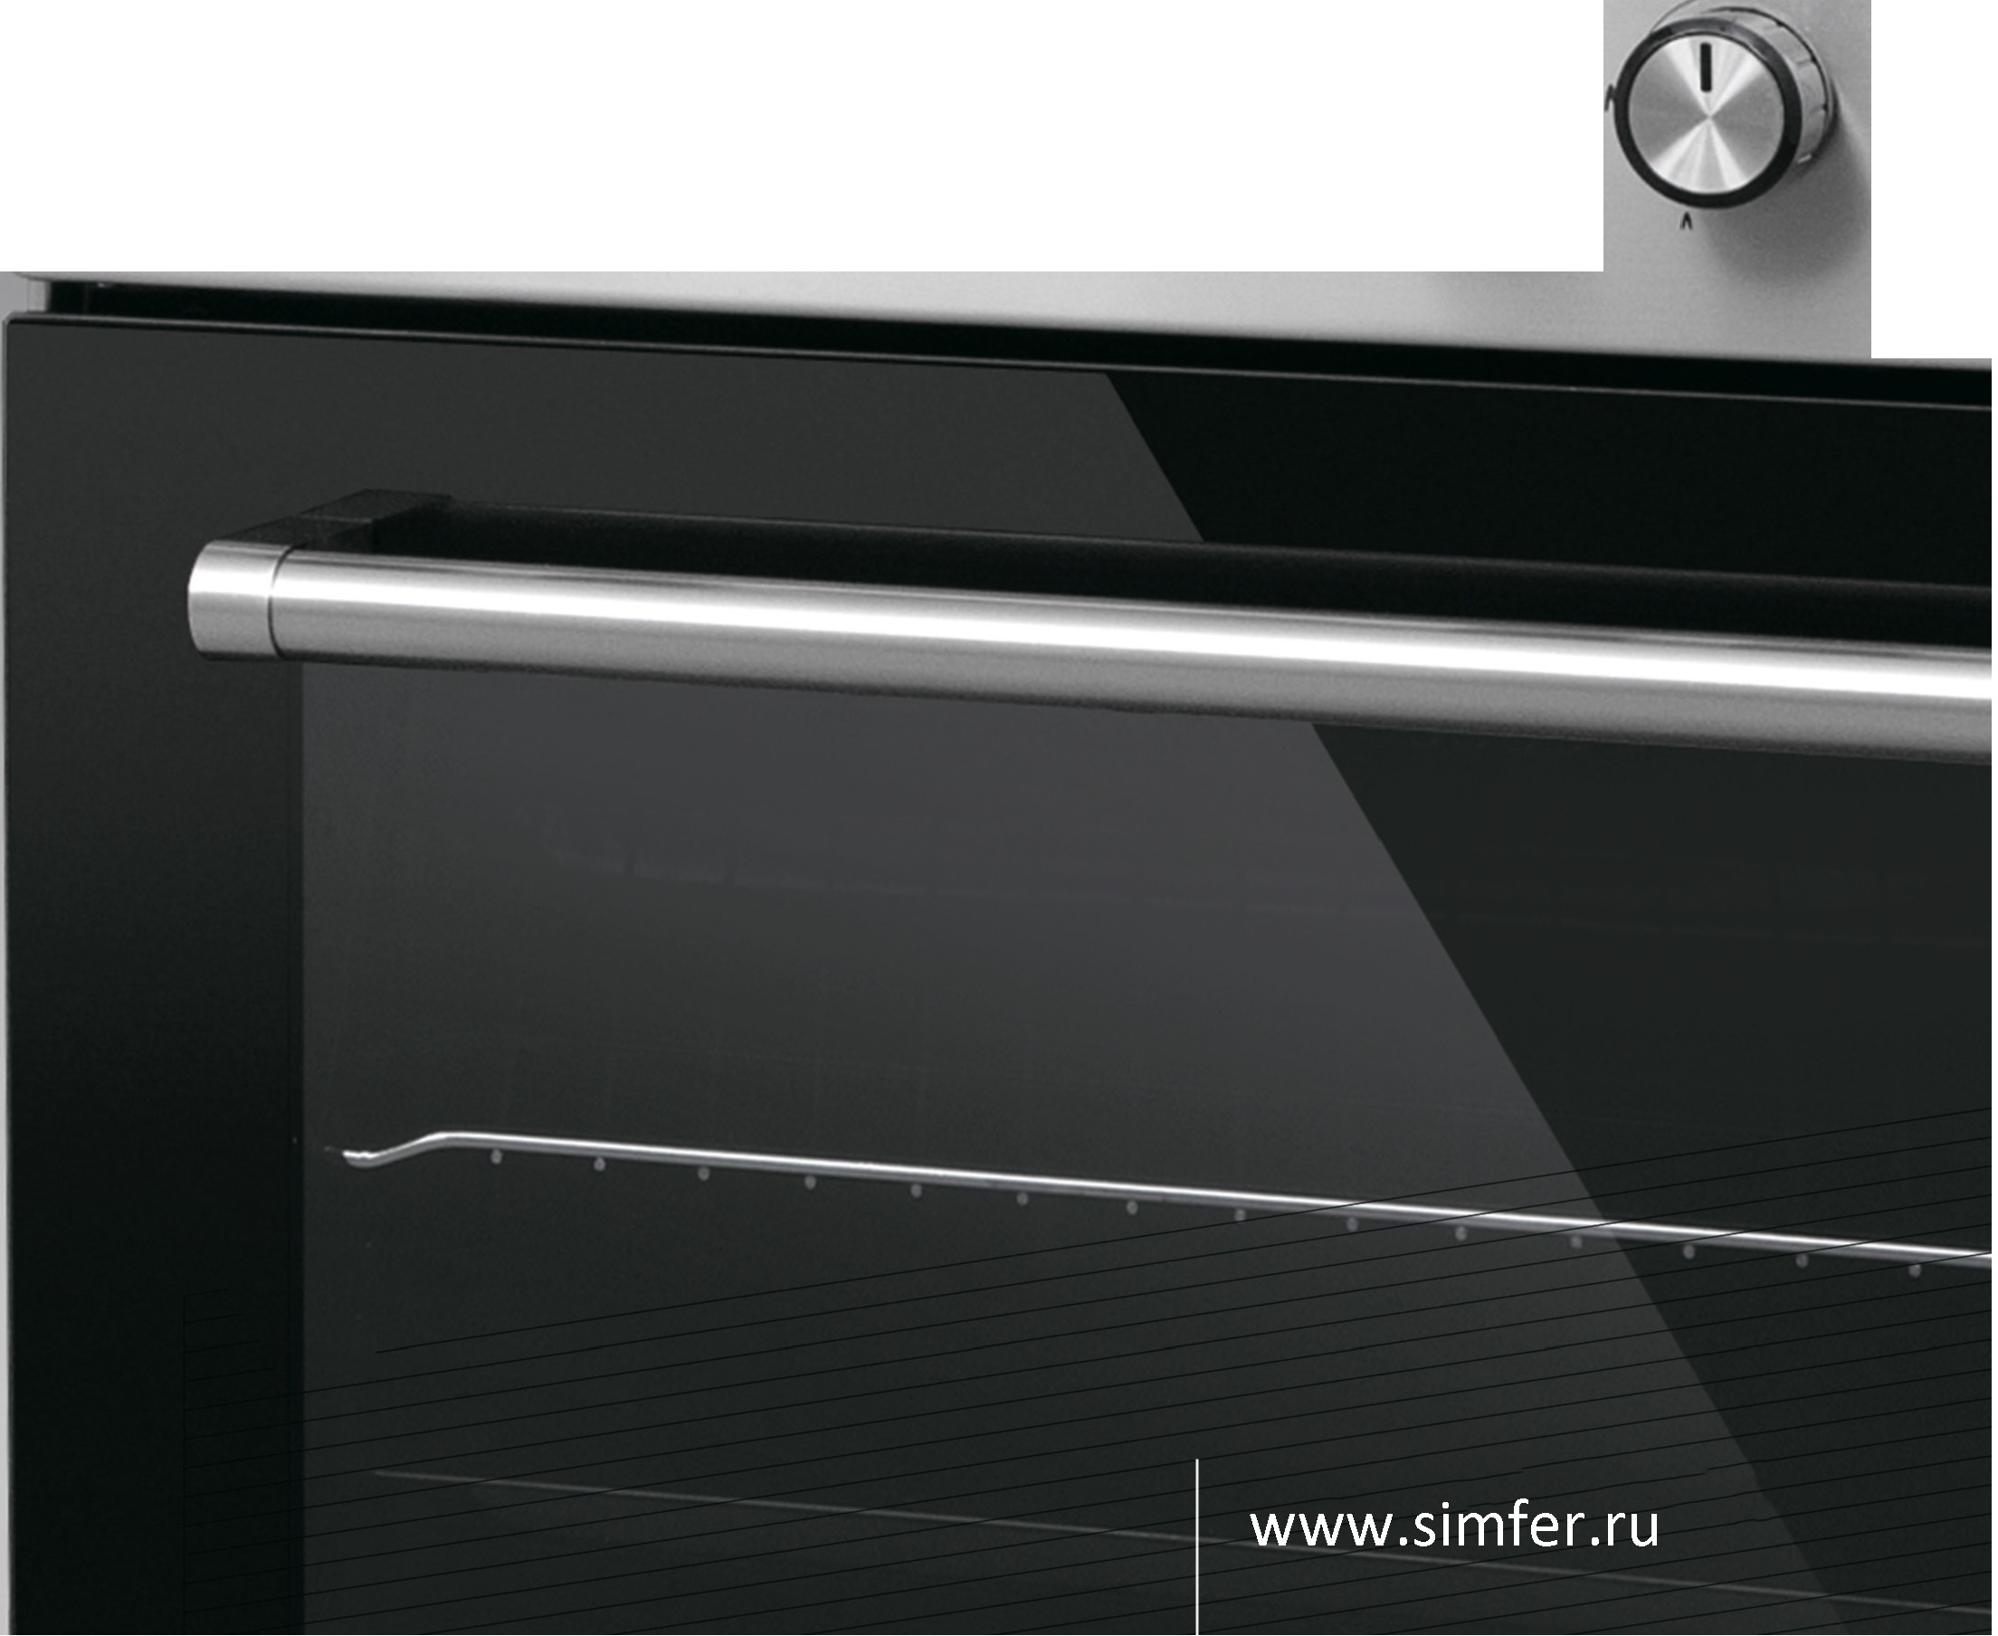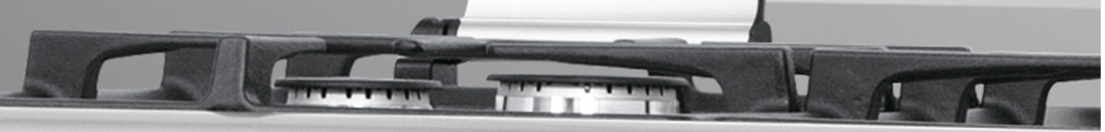

•

V1 HHOBa U,ltlOHHble TeX HOJlO rltl lt1

u u

B Henpe B301tl,l1,e HHOM ,l1,lt13 a 1t1 He

Henpe B30 ,LJ,e HHbl ,LJ,1t13a H

•

-

00

00

00

01 0

A

# •



 I "TEX HV1LI ECKV1E XA PA KTE PV1CT V1 KV1

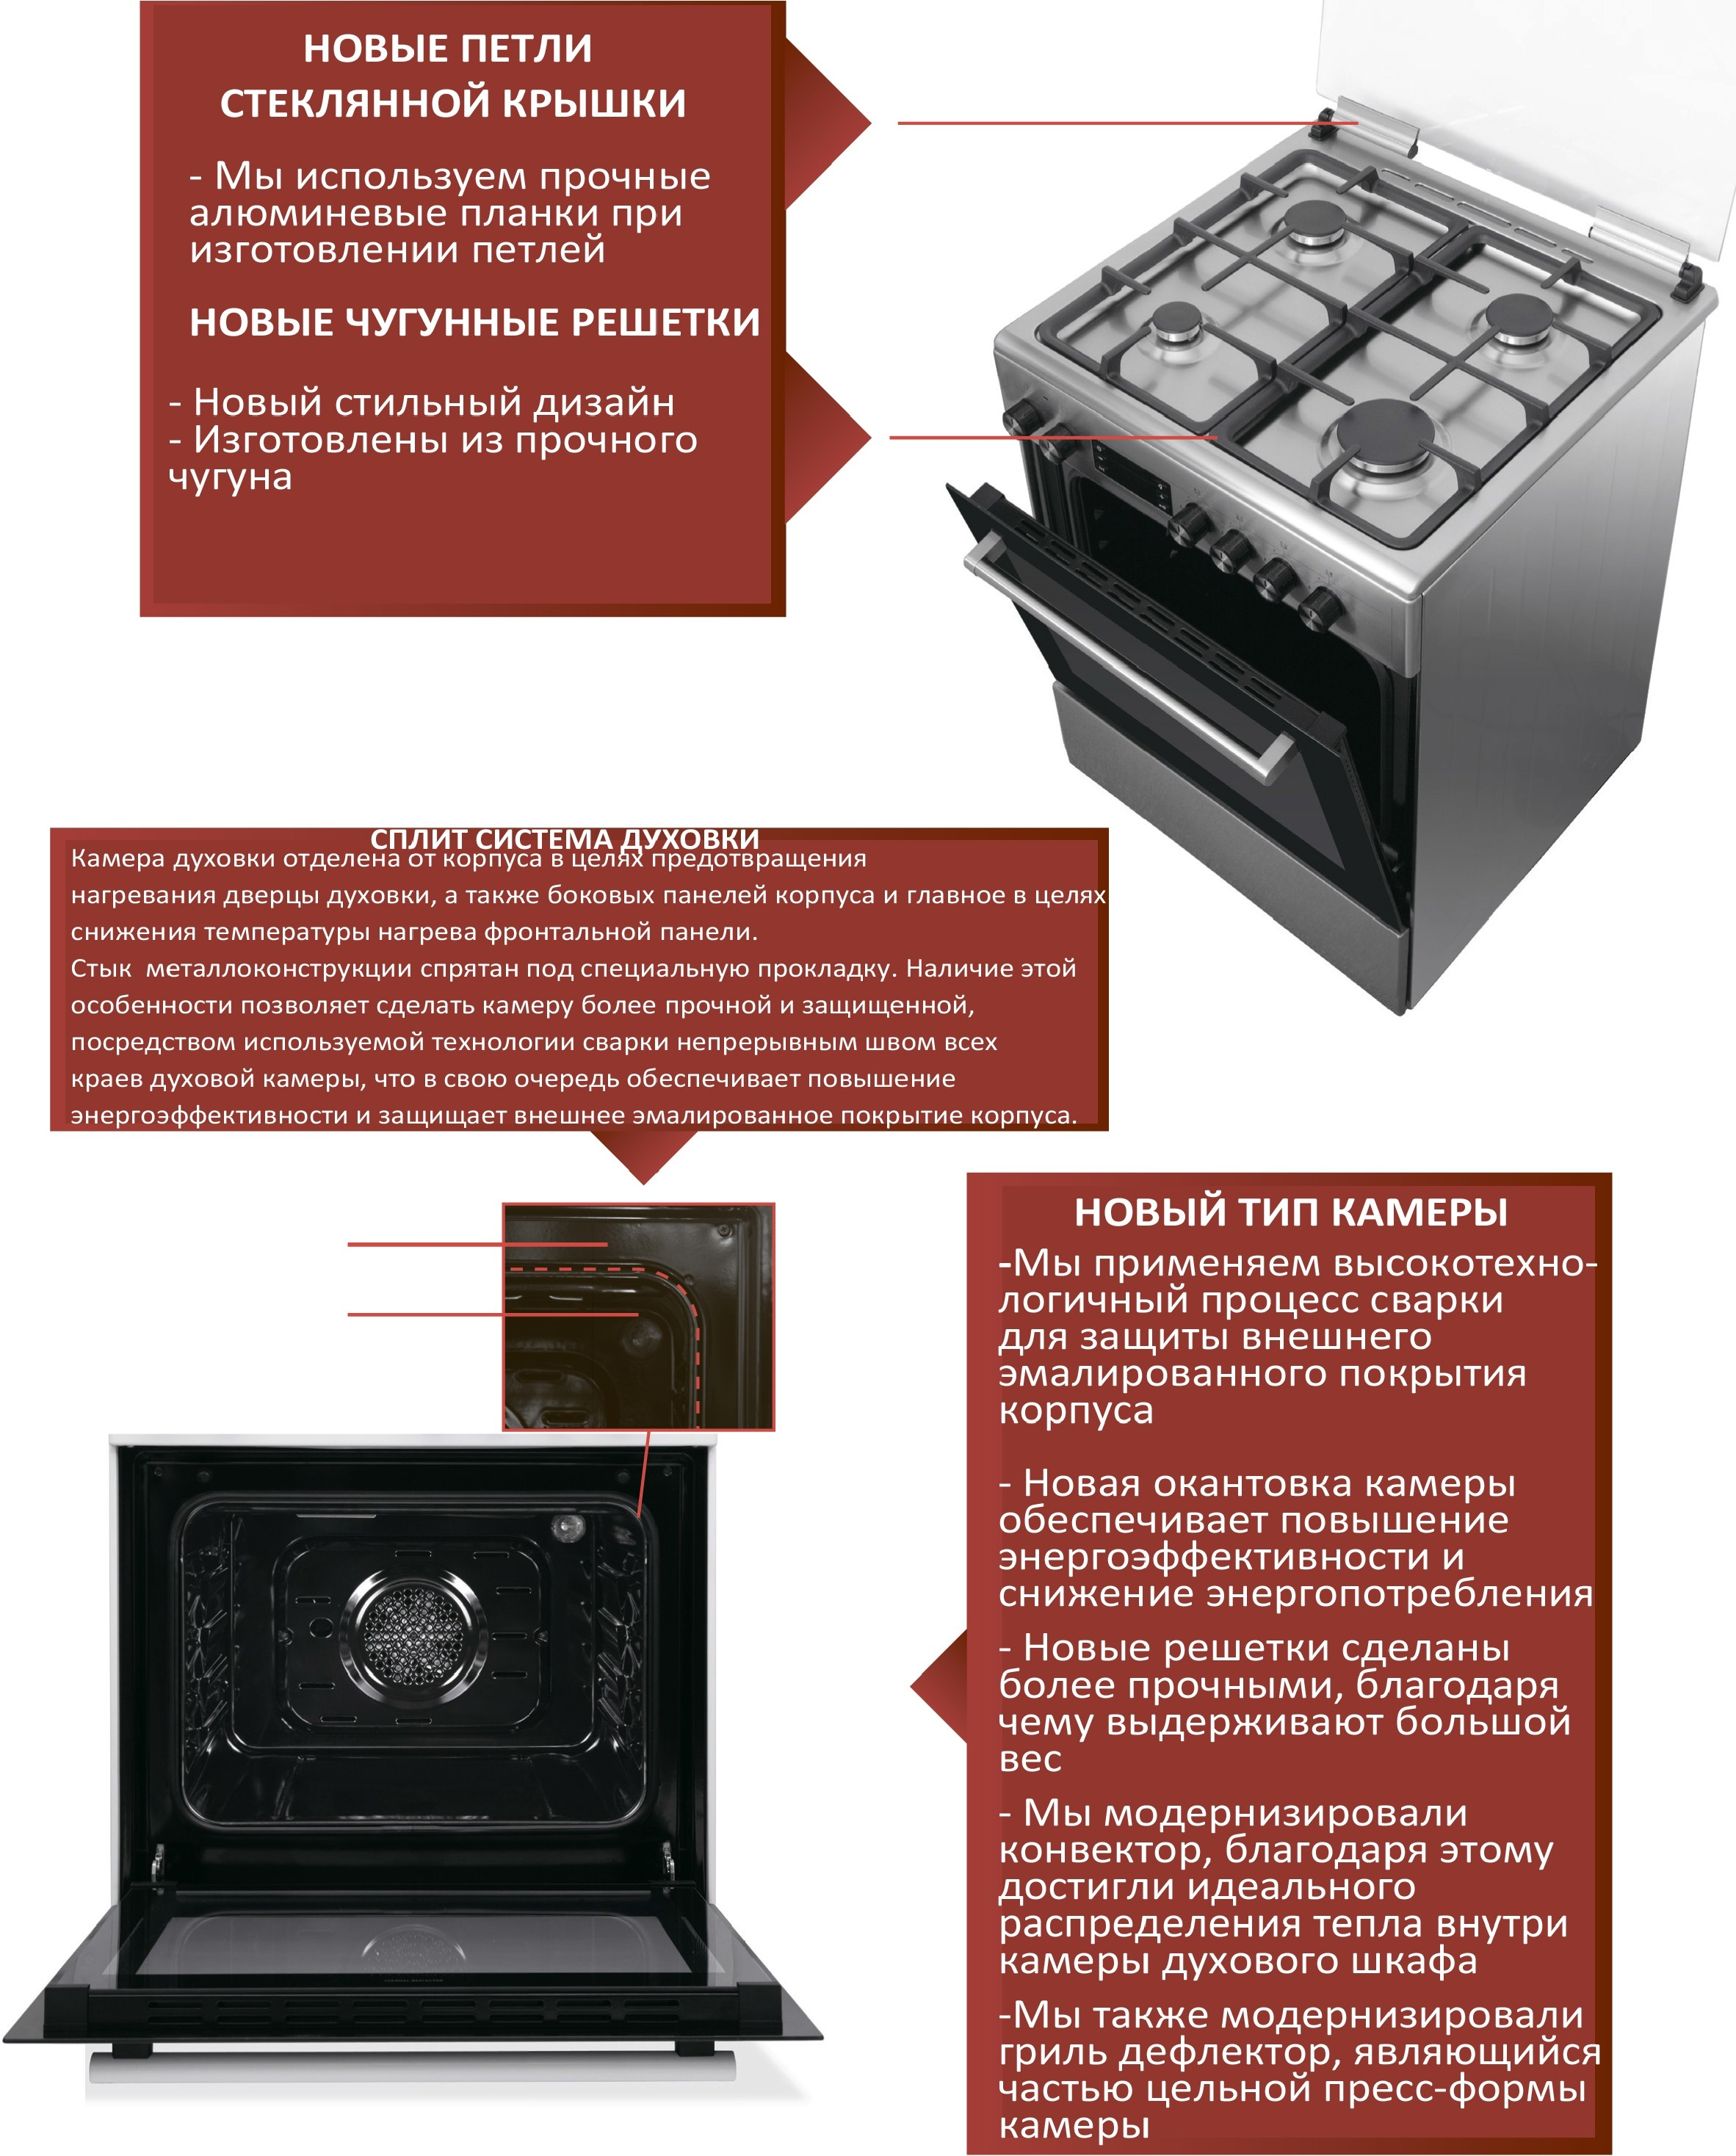

OKa HTOBKa KaMepb1

KaMepa

 I er TEX HV1 ECKV1E XA PA KTE PV1CT V1 KV1



•

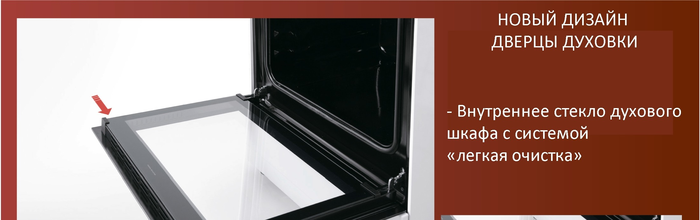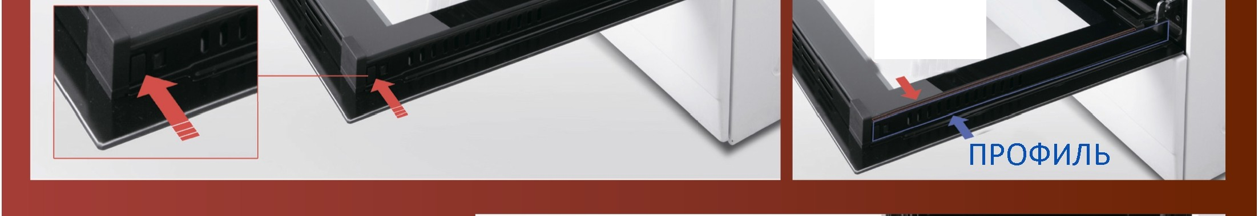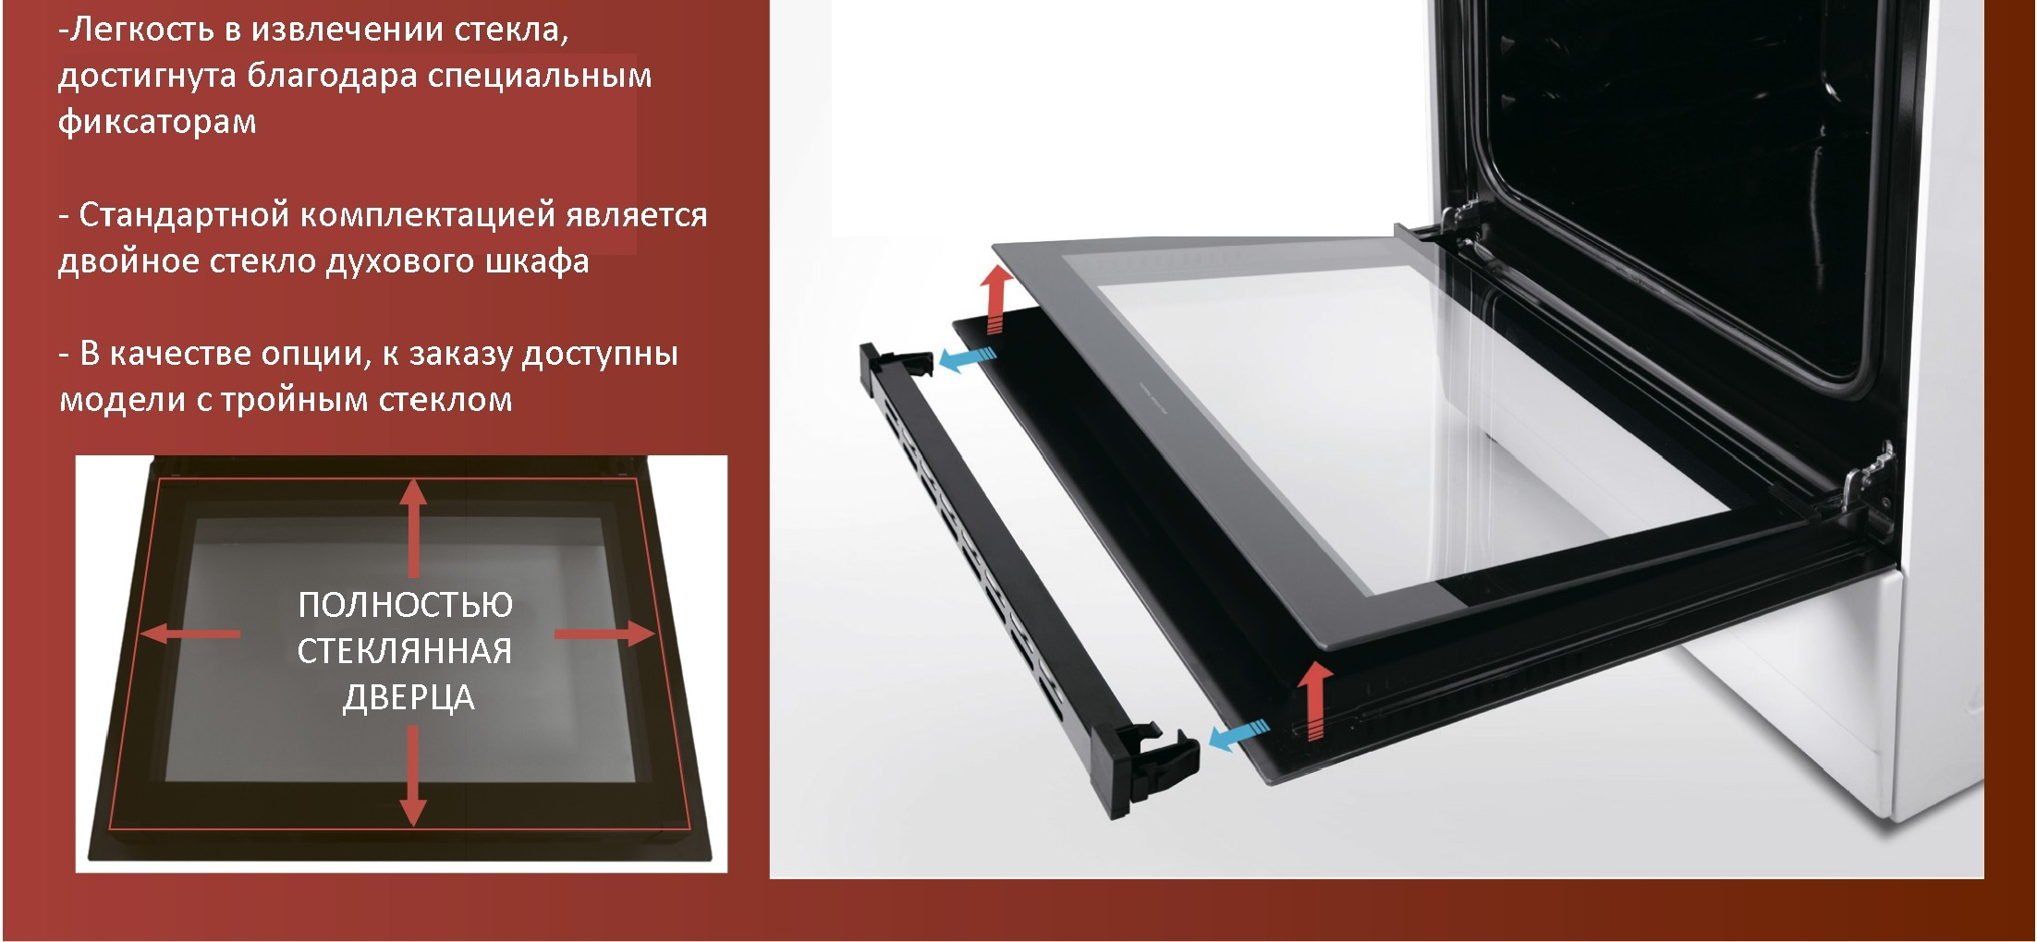

CTE KJlO

flE rKOCTb B 1113B/lE 4 EHll1111 CTE K/lA

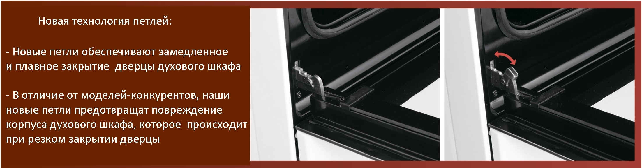

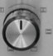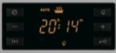

**HOBAfl YnPO'-I HEHHAfl KOHCTPYKl..llt1fl**

**METAJl/ll-1'-I ECKO PAMbl AYXOBO nlllt1Tbl**

- B *l.\efl RX* ynpo4 HeH 11R pa M04 HOH KOHCTPYK L.\ 1111

AYXO Boro W Kacj>a, 11cnO/lb3YIOTCR Ka K nepeAH11e Ta K 11 3aAH 11e MeTa/l/ll14 eCK l1e o60HMbl

- EinaroAa PR Aa HHOMY MeTann114 ecK 0My ynflOTH eHl1IO, 11CnO/lb3YeMO MY BO BCeM

MOAeflbHOM PRAe nn11T, Haw a npOAYK L\11R cTana

*6onee* YAapoycTOH4 11BOH

# •



I **TEX HV1LI ECKV1 E XA PA KTE PV1CT V1 K V1**

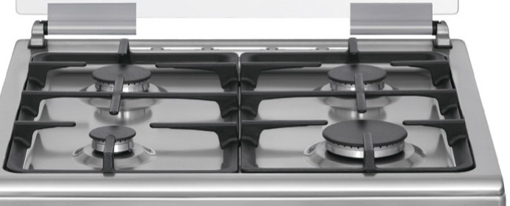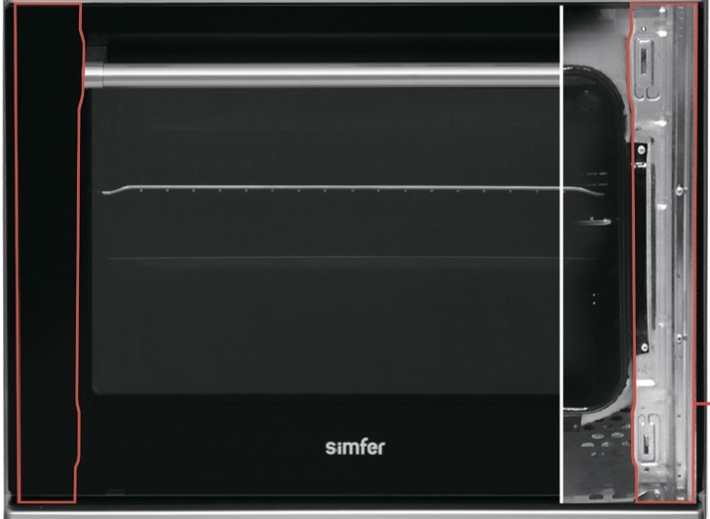

-

•

•

•

•

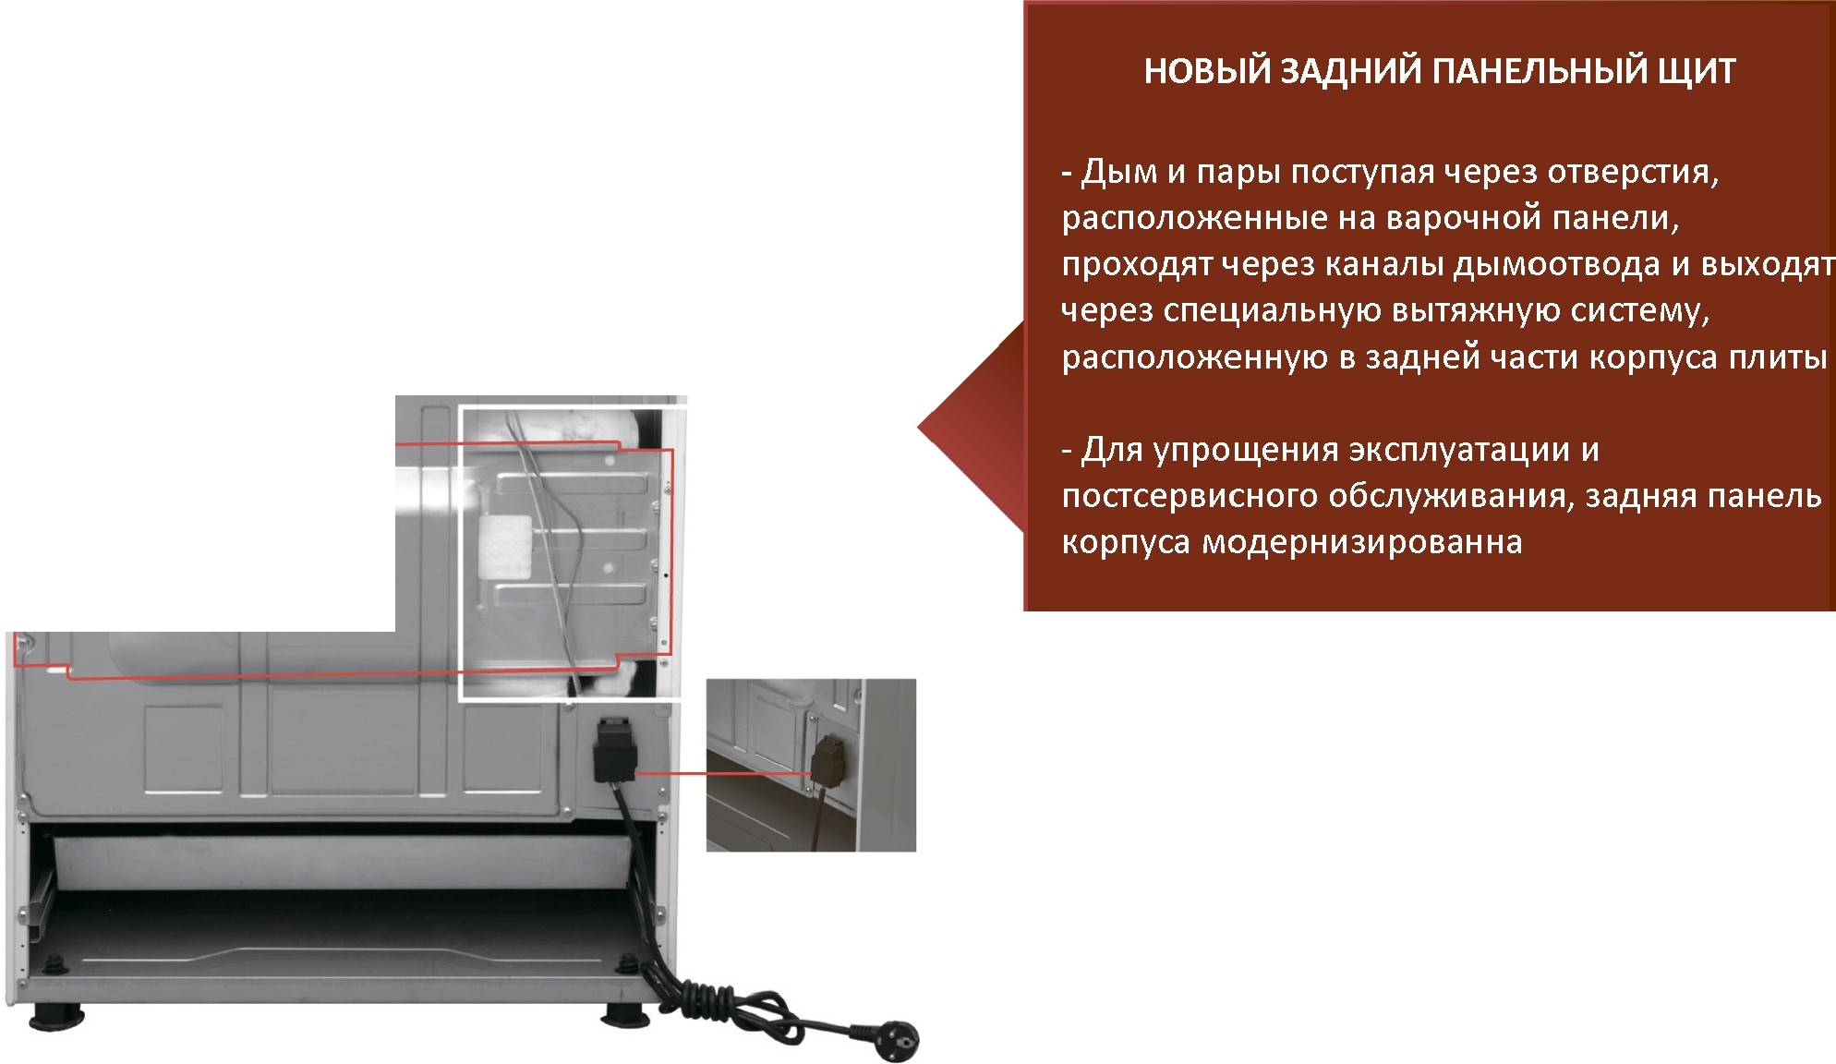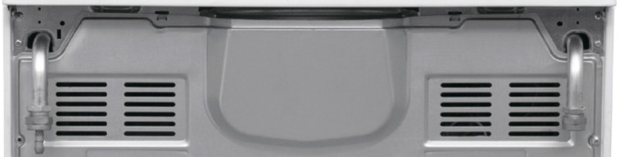

••••••••••••••

•••

••••••••••••

•



 I TEXH ECK E XAPAKTEP CT K



•

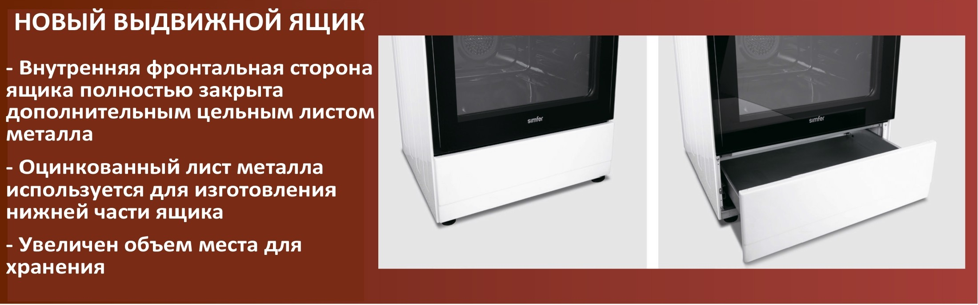

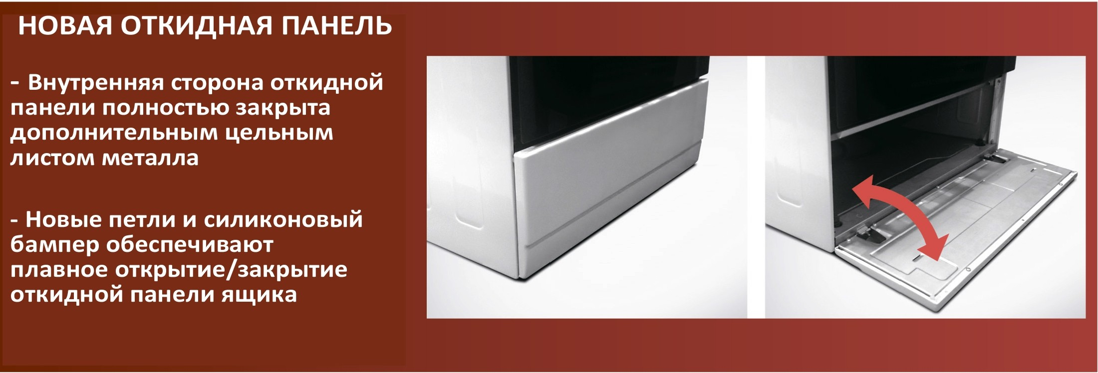

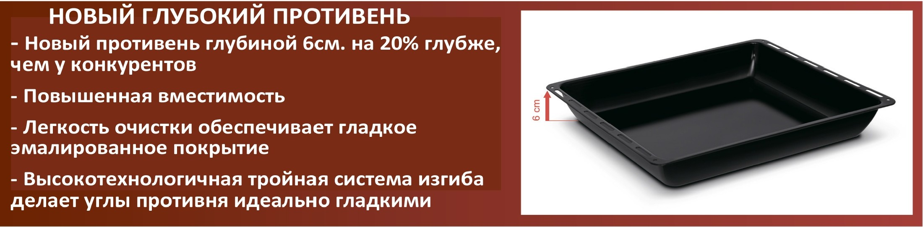



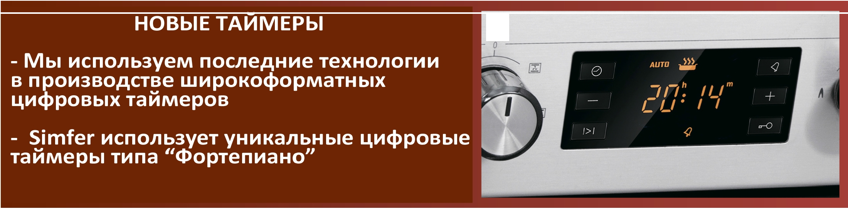

D

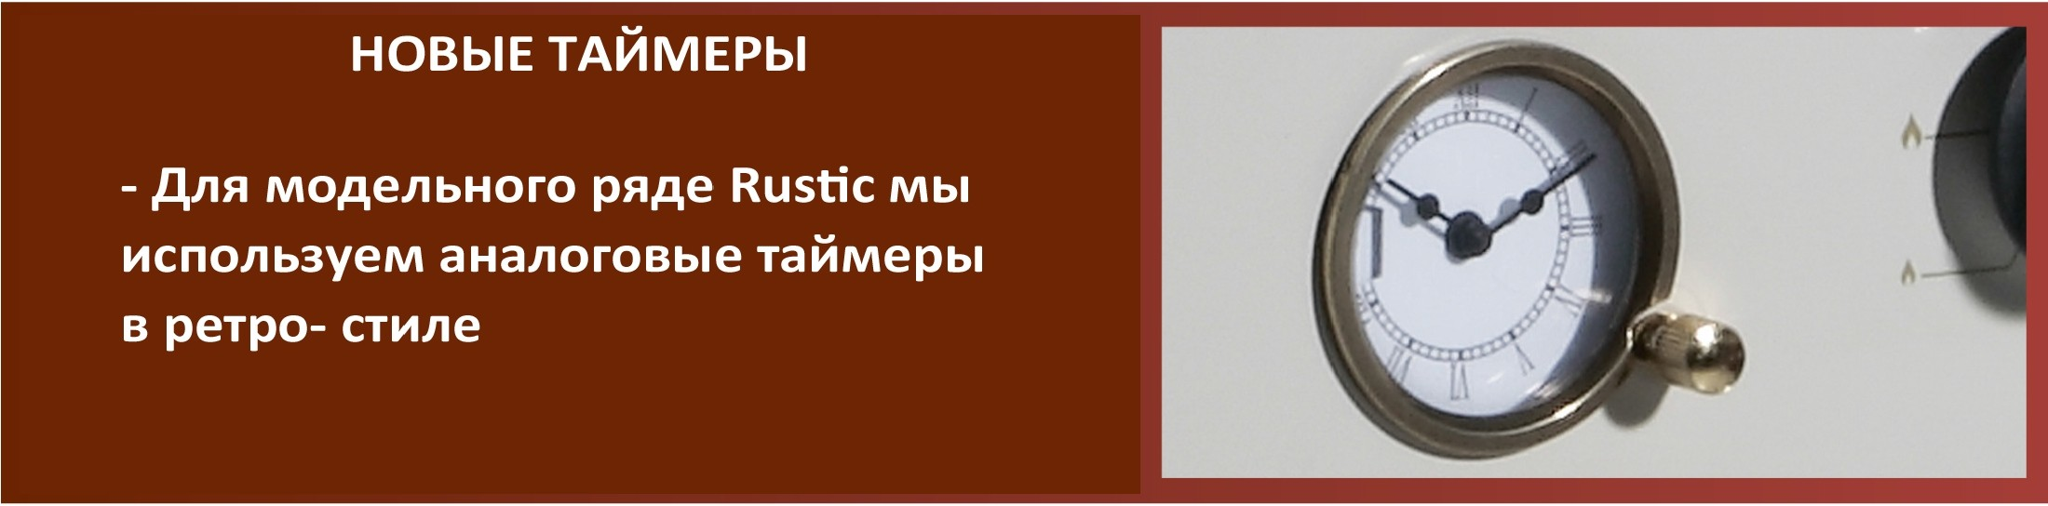

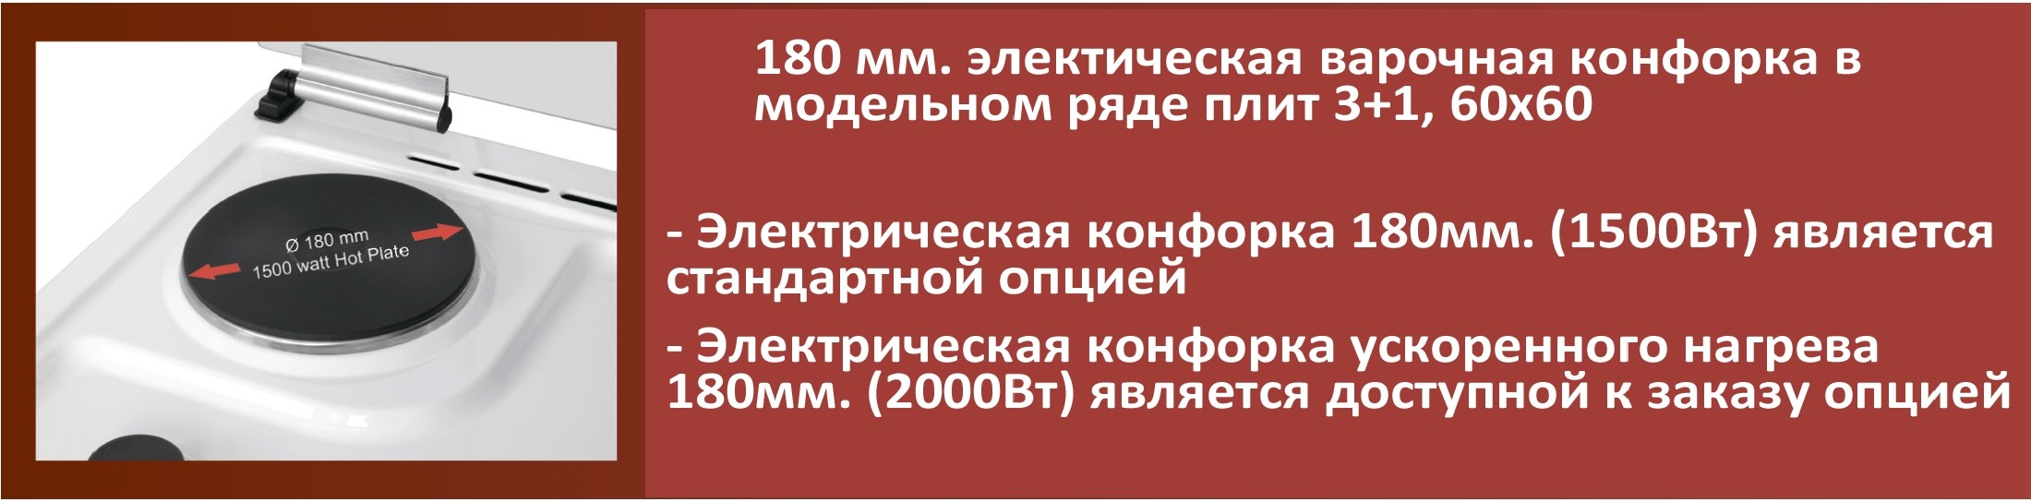

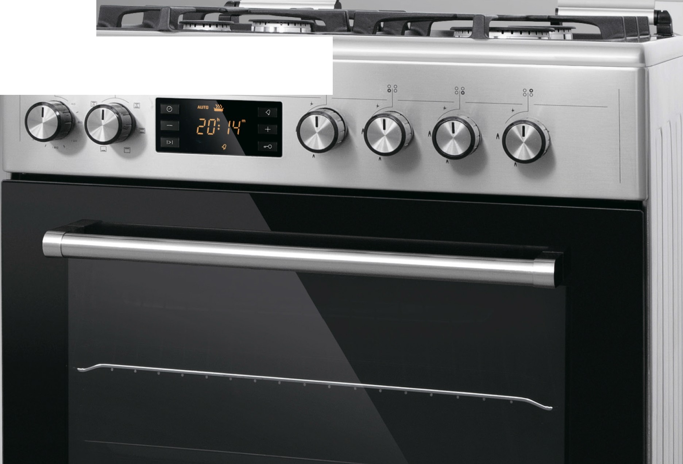

I

•

-

g g